Linwood E. Howe Elementary School
Family Night Astronomy Star Party
Friday, November 21, 2008
6:00 – 8:00 pm
Please join fellow Linwood Howe families for a night of star, moon, and planet gazing on the playground. We thank the South Bay Astronomical Society and Dr. Mark Moldwin for their guidance, and their telescopes.

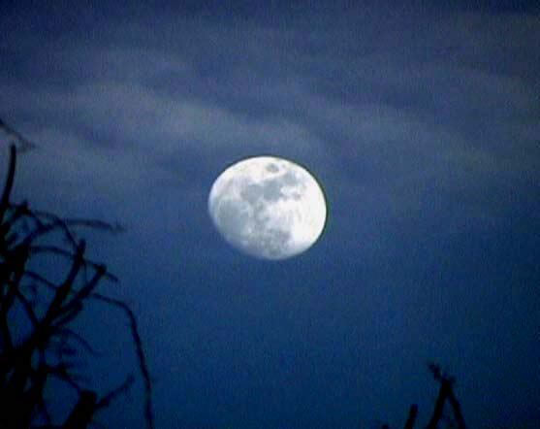
WAXING MOON

